Hong Kong Exchanges and Clearing Limited and The Stock Exchange of Hong Kong Limited take no responsibility for the contents of this announcement, make no representation as to its accuracy or completeness and expressly disclaim any liability whatsoever for any loss howsoever arising from or in reliance upon the whole or any part of the contents of this announcement.

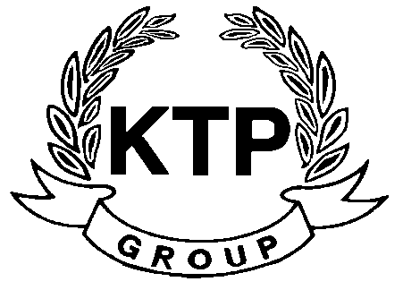
KTP HOLDINGS LIMITED
港台集團有限公司*
(Incorporated in Bermuda with limited liability)
(Stock Code: 645)

ANNOUNCEMENT PURSUANT TO RULE 3.7 OF THE TAKEOVERS CODE

Reference is made to the announcements (the “Announcements”) of KTP Holdings Limited (the “Company”) dated 5th August 2010, 10th August 2010 and 13th September 20010 regarding the possible disposal of the Company’s shareholdings interests by the Controlling Shareholder (“Possible Disposal”). Unless otherwise defined, terms used in this announcement shall have the same meanings as those used in the Announcements.

The Company wishes to update its shareholders that, as informed by the Controlling Shareholder, no progress has been made relating to the Possible Disposal and no agreement whatsoever has been reached by the parties as at the date hereof. At this stage, the Controlling Shareholder is unable to confirm whether they will proceed with the proposed transaction or not. Agreement may or may not be successfully reached between the parties concerned and there is no assurance that the proposed transaction will proceed.

Shareholders and potential investors of the Company should exercise extreme caution when dealing in the shares of the Company.

This announcement is issued pursuant to Rule 3.7 of the Takeovers Code. Shareholders will be informed of any further development with regards to the Possible Disposal as and when necessary and on a monthly basis pursuant to Rule 3.7 of the Takeovers Code until an announcement of a firm intention to make an offer or of a decision not to proceed with an offer is made in compliance with the Takeovers Code.

By Order of the Board
KTP Holdings Limited
Lee Chi Keung, Russell
Chairman
Hong Kong, 8th October 2010

As at the date of this announcement, the executive directors of the Company are Mr. Lee Chi Keung, Russell (Chairman), Ms. Yu Mee See, Maria and the independent non-executive directors are Mr. Ng Wai Hung, Mr. Lee Siu Leung and Mr. Yuen Sik Ming.

Made by the order of the Board, the directors of which jointly and severally accept full responsibility for the accuracy of information contained in this announcement and confirm, having made all reasonable inquiries, that to the best of their knowledge, opinions expressed in this announcement have been arrived at after due and careful consideration and there are no other facts not contained in this announcement, the omission of which would make any statement in this announcement misleading.

*For identification purpose only

